**PROJECT DESCRIPTION**

This interdisciplinary project aims to combine the real-time sensing of physical and mental stress in humans with state-of-the-art active soft robotic exoskeletons towards the development of integrated, intuitive, and responsive human-machine systems for use in stressful industrial work environments. Through the real-time monitoring of physiological and mechanically intrinsic measures of stress, we seek to identify the most appropriate sensor suite for identifying mental and physical stressors and to act on the detection of stress. Through the integration of a person’s intent, perception, and behavior in a stressful industrial setting, we will examine how successfully a soft robotic exoskeleton can act to alleviate physical and mental stress in a human user. Thus, our goal is both to lay foundational benchmarks in modern human-machine interfaces, and to build an engineered system which can be of real benefit to workers in industrial settings.

**RATIONALE**

Seamless interaction between humans and machines is one of the grand challenges of modern science, which requires integrated efforts across mechatronics, applied computing, and behavioral and cognitive neurosciences. Identification of human intent and perception, in conjunction with the ability to affect and actuate, may lead to singular transformations in human-machine interactions and contribute to our understanding of human intent, perception, and behavior and the interaction with intelligent engineered systems. Excessive state anxiety or stress has been shown to have detrimental effects on physical and cognitive performance (Martens and Landers, 1970; Carron, 1971; Noteboom et al., 2001; McHugh et al., 2010). Increased attentional bias can occur under the presence of anxiety or psychological stress (Miranda et al., 2001; El Khoury-Malhame et al., 2011), which may be maladaptive in complex work environments. Furthermore, as cognitive efficiency is decreased under conditions with either high stress or anxiety (Hardy, 1999; Mullen and Hardy, 2000; Mandrick et al., 2016), it presents a risk for injury, particularly as we age. Physiological changes arise from high stress and anxiety conditions which can be monitored in real-time (Lee et al., 2010; Mateo et al., 2012; Williamon at al., 2013; Garcia-Rubio et al., 2017). However, the sensor which provides the most informative signal for a potential response during the performance of physical tasks in industry remains an open question. Work-related musculoskeletal disorders due to use of powered hand tools are a serious problem with the industrial workforce (U.S. Bureau of Labor Statistics, 2016). The use of external devices and recently exoskeletons to alleviate physical stress on the body have been explored. Thus, through the integration of a person’s intent, perception, and behavior in a stressful industrial setting together with a soft robotic exoskeleton this research addresses the NSF CMMI M3X’s interest in an integrated treatment of human intent, perception, and behavior in interaction with embodied and intelligent engineered systems as mediated by motor manipulation.

**RESEARCH OBJECTIVES**

**1. *Identify* *minimal sensor suite for monitoring anxiety and stress changes in real-time.*** Through the use of simulated virtual work environments and integration of both physiological and mechanically intrinsic measures, we will seek to identify a minimal sensor suite for detection of anxiety and stress in real-time.

**2. *Create and validate stress-relieving active soft robotic exoskeleton*.** Through the use of state-of-the-art soft robotic architectures, we will seek to create and validate the ability of a soft robotic exoskeleton to alleviate physical stress and improve performance accuracy via redistribution of loads and actuation.

**3. *Validate body-in-the-loop control of soft robotic exoskeleton***. Integrating the sensor suite that can most accurately assess changes in stress or anxiety during the performance of industrial tasks, and the actuation pattern that can best alleviate mental and physical stress and improve performance, to systematically define how signals of stress interact with machine and drive what the machine is doing.

**BACKGROUND**

*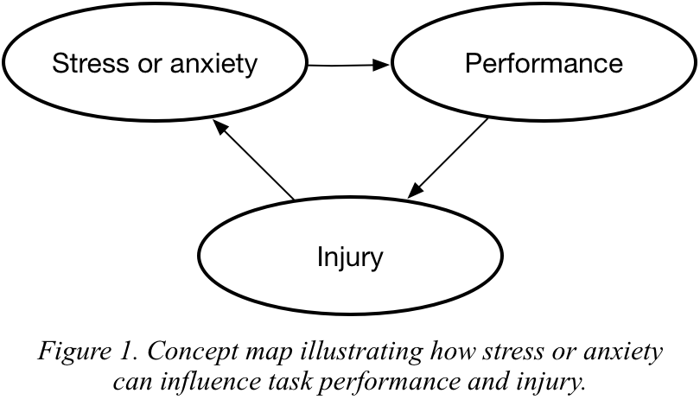Effect of stress or state anxiety on task performance and risk of injury*. Excessive state anxiety or stress has been shown to have detrimental effects on physical and cognitive performance (Martens and Landers, 1970; Carron, 1971; Noteboom et al., 2001; McHugh et al., 2010). Even when performance is maintained, cognitive efficiency is decreased under conditions of high stress or anxiety (Hardy, 1999; Mullen and Hardy, 2000; Mandrick et al., 2016), which increases the sense of effort during a task. While the inverted U relationship between anxiety or stress and performance has been well established (Martens and Landers, 1970; Carron, 1971), questions remain about the underlying model that might best explain how human performance is modulated by high task accuracy demands and anxiety or stress. The processing efficiency theory (Eysenck et al., 2007; Derakshan et al., 2009) and cognitive-energetic framework (Hockey, 1997) provide a model for understanding the effect of stress on human performance but require further confirmation in work environments. Increased attentional bias can occur under the presence of anxiety or psychological stress (Miranda et al., 2001; El Khoury-Malhame et al., 2011), which may be maladaptive in complex work environments and lead to an increased risk of injury. Injury itself can lead to increased stress in the human body and exacerbate stress or anxiety, which would lead to a downward spiral (Fig. 1).

*Work-related injuries.* Of all occupational injuries and illnesses that require days away from work in the US, approximately one-third are due to work-related musculoskeletal disorders (WMSD) (U.S. Bureau of Labor Statistics, 2016). These WMSD resulted in a moderately high incidence rate of 29.8 cases per 10,000 full-time workers, with a median of 12 days away from work (U.S. Bureau of Labor Statistics, 2016). Musculoskeletal disorders are painful disorders associated with soft tissue (i.e., muscle, tendon, ligament, cartilage, nerves) (Wang et al., 2015), that can occur from either an acute bout of excessive physical effort or prolonged exposure to repetitive stress (Inyang et al., 2012). WMSD can manifest as carpal tunnel syndrome, tendonitis of the shoulder, elbow, wrist or other joints, herniated discs, sciatica, or low back pain (Albers and Estill, 2007; Wang et al., 2015). In particular, occupations that have repetitive motions, high force exertion, awkward body postures, high impact force, constant vibration, and extreme temperatures pose a significant risk for WMSD (Wang et al., 2015). Some tasks associated with WMSD are lifting and carrying heavy objects, working overhead, using handheld power-actuated fastening tools, and using high impact tools such as jackhammers or riveters (Hagberg 2001; Albers and Estill, 2007). Thus, devising ways to protect the worker and mitigate the effect of these risk factors is necessary to prevent WMSD and improve worker quality of life and quality of work.

*Effect of age on risk of injury in the workplace*. As the proportion of older adults in the general population continues to dramatically increase over the next several decades, treatment and prevention of injury in the aging workforce will become an increasingly salient problem. Workers over 55 years of age represents the nation’s fastest growing segment of the working population (CDC, 2011) and have higher rates of falls in the same level, fractures, and hip injuries compared to younger workers (CDC, 2011; Son et al., 2014; Phillips et al., 2015). A significant risk of musculoskeletal and brain injury is present in older workers across numerous industries (Higgs et al., 1993; Li et al., 1999; Kemmlert et al., 2001; Cherry et al., 2005; Colantonio et al., 2009; Konda et al., 2015), including an increased risk of fatality (Dong et al., 2014). However further research is needed on the best practices for injury prevention in older workers (Delloiacono, 2015).

*Effect of stress and anxiety on task performance and risk of injury*. Building upon a model between anxiety and impaired balance function (Hadjistavropoulos et al., 2011), Young and Williams provide a theoretical framework for how anxiety influences physical performance in older adults via changes in attentional processes that impact motor control and the retention of salient sensory information from the environment (Young and Williams, 2015). Consistent with the role of emotional processes in guiding volitional movement, anxiety is expected to modulate fight-or-flight responses and overall muscle tone via projections from the hypothalamus to the brainstem (Takakusaki et al., 2004). Given the increase in neuromuscular noise expected during stressful conditions, it is not surprising to note an impairment in steadiness in a motor task due to an imposed stressor (Noteboom et al., 2001).

*Physiological and mechanically intrinsic measures of stress or state anxiety*. Anxiety can be defined as a multisystem response to a perceived threat or danger. Anxiety brings about a variety of physical symptoms, such as cardiac acceleration, sweating, and tremors. Physiological changes arise from high stress and anxiety conditions which can be monitored in real-time (Lee et al., 2010; Mateo et al., 2012; Williamon at al., 2013; Garcia-Rubio et al., 2017). Using frequency-specific fluctuations in heart rate dynamics, together with skin conductance or blood flow changes in prefrontal cortical areas, changes in stress and anxiety can be monitored in real-time. In addition, anxiety has been linked with increased muscle co-contraction and altered body movements while performing volitional movements (Adler et al., 2005; Yoshie atl., 2009; Wuehr et al., 2014; Brandt et al., 2015; Cleworth et al., 2016). Thus, changes in movement strategies and efficiency of movement may provide mechanically intrinsic measures of anxiety in adults. However, the sensor suite which provides the most informative signal for sensing stress changes during the performance of cognitively and physically demanding tasks in industry remains an open question.

*Industrial assistive devices and exoskeletons*. A number of devices and exoskeletons have been explored to assist industrial workers to prevent injury, or to augment workers to allow them to perform enhanced tasks. Equipois, Lockheed Martin, and EXHAUSS have created commercially-available passive, unpowered mechanical arms for transferring the load of heavy tools, up to 16.3 kg, away from the arms through external support structures that are attached (Fig. 2b-c) (Goldman et al., 2014; Kincaid et al., 2015), or not attached to the worker (Fig. 2a) (Equipois, 2016). Otherlab (which recently spun off as Roam Robotics) has proposed an inflatable pneumatic exoskeleton for elbow actuation (Fig. 2d) (Otherlab, 2016; Roam Robotics, 2017). The devices and exoskeletons are large, heavy, rigid and, if powered, require complex control for precision movement. All are quite bulky. Thus, there is a clear need for wearable smart personal protective equipment designs that sense when to protect workers from internal injury due to exposure to overexertion, repetitive motions, and vibration, while packaged in a lightweight and unobtrusive design.

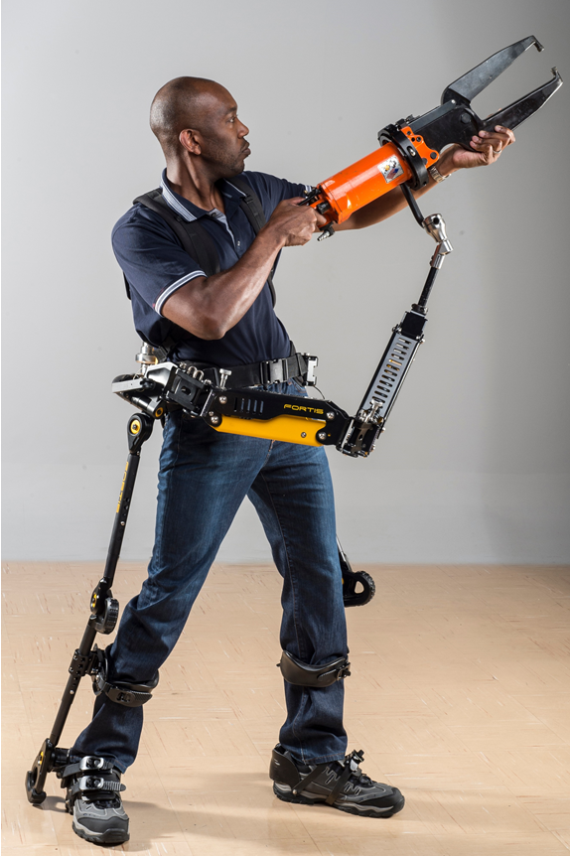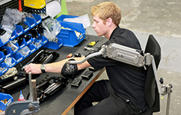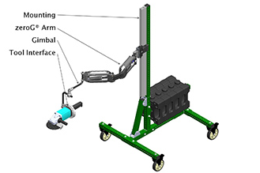

(a)

(b)

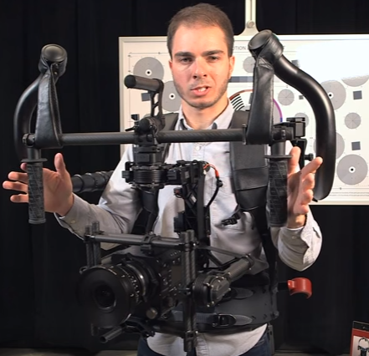

(c)

*Fig. 2. Sample rigid exos for handling heavy loads. (a) X-Ar and zeroG by Equipois, (b) FORTIS by Lockheed Martin, (c) gimbal-driven exoskeleton (with camera support package) by EXHAUSS, and (d) soft pneumatic elbow actuation and support by Otherlab (now Roam Robotics)*

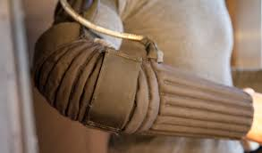

(d)

*Soft robotics.* Soft robots have become popular because of their unique advantages such as adaptability, and safe interactions with the environment with minimal controls (Ilievski, et al., 2011; Laschi, 2015; Rus and Tolley, 2015). They differ from conventional robots as they lack rigid and stiff members, actuators and sensors. Soft robots are usually bioinspired comprising of stretchable skins, tendons, pressurized fluids, soft muscles and fibers. Popular actuation schemes include hydraulics and pneumatics (Aschenbeck, et al., 2014; J Bishop-Moser & Kota, 2013; Neppalli et al., 2007), shape memory alloy actuation (Seok et al., 2013), and driving cables using motors (Wehner et al., 2013). The soft and flexible nature of these structural and actuation members enable direct translation of these technologies to wearable devices (Polygerinos, et al., 2015). In the proposed work, we will investigate unique architectures of soft fluidic actuators that can alleviate stress and anxiety in high demanding virtual work environments.

*Innovation.* Novel platforms for continuous real-time monitoring of physiological and physical stress will allow the human user to directly shape the assistance that an *active soft robotic exoskeleton* can provide and provide us with a better understanding of how a machine can best respond to changes in stress to alter physical function and potentially alleviate the risk of injury during the performance of high demanding tasks. Through the construction of novel models of human-machine feedback, we seek to provide a testbed for sensing anxiety and stress quickly enough and with enough precision to actuate a soft robotic exoskeleton, and construct a stable feedback loop. The results of this work will answer both theoretical and applied physiological questions:

* How does local actuation of a smart soft robotic exoskeleton while a person is performing high demanding tasks in a complex environment alter physical performance and the risk of injury?
* What minimal sensor suite can best provide information about real-time changes in mental and physical stress to initiate a timely response from a smart soft robotic exoskeleton?
* What combination of local actuation and load redistribution can best alleviate mental and physical stress during the performance of high demanding tasks?

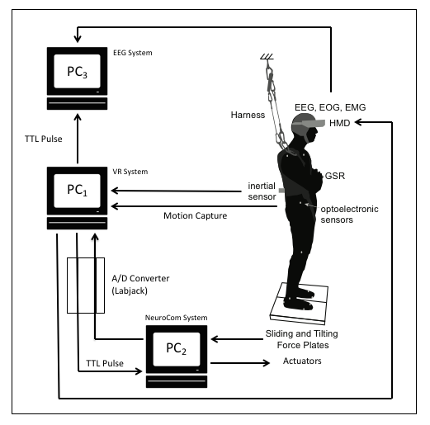

**PRELIMINARY RESEARCH RESULTS AND EXPERTISE**

*Virtual reality environment development*. Through the use of virtual reality (VR), participants can be safely exposed to conditions of increased threat to examine the role of anxiety (Yelshyna et al., 2016), and be presented with precisely timed complex visual stimuli to enhance the sensitivity and reliability of experimental results. VR is capable of inducing the psychological effects comparable to real world height manipulations (Cleworth et al., 2012), while avoiding the associated risks to health and safety. Drs. Sowers and Hernandez have developed a system that allows for the simultaneous recording of neural, physiological, and behavioral data in an immersive VR environment while implementing sensory and mechanical perturbations to evaluate alterations in sensorimotor integration under conditions with high postural threat, which may provide a powerful testbed for examining the effect of stress and anxiety on physical performance in adults (Fig. 3 Widdowson et al., 2015).

Figure 3. Hardware setup and data flow for previous analysis of anxiety on postural control, using electro- encephalo-, oculo-, and myo- graphy (EEG, EOG, EMG), galvanic skin response (GSR), and inertial and optoelectronic sensors for motion capture.

*Sensing stress and anxiety changes*. Through the use of functional near infrared spectroscopy (fNIRS) that monitor hemodynamic changes under the skin, we have demonstrated the ability to monitor changes in prefrontal cortical activity in older adults and clinical populations during gait (Hernandez et al., 2016; Chaparro et al., 2017). Given the expected changes in neural efficiency due to anxiety and stress, the use of fNIRS provides an objective quantification of attentional demands, which can complement other physiological measures such as skin conductance (i.e., galvanic skin response or GSR), muscle activation, and heart rate variability. Together with measurements of human motion recorded via standard motion capture methods, force sensors, and portable inertial measurement units, we will use our expertise in the integration and synchronization of multimodal recordings to examine the minimal sensor suite that can best provide information about real-time changes in mental and physical stress in humans.

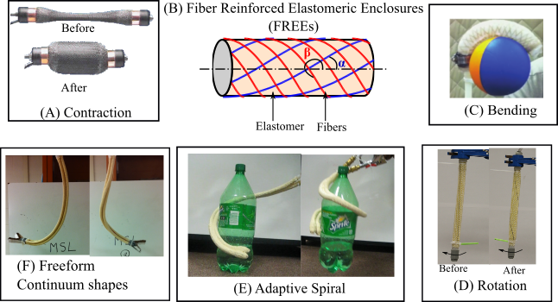

*Soft robotic exoskeleton actuation.* Dr. Krishnan has developed an arsenal of soft fluidic actuators known as Fiber Reinforced Elastomeric Enclosures (FREEs). FREEs are composite equivalents of the popular McKibben muscles (Bishop-Moser et al., 2013; Bishop-Moser et al., 2012; Krishnan, 2014; Krishnan et al., 2015; Singh & Krishnan, 2015, 2017) (Fig. 4A), which are inspired by the structure of muscular hydrostats, trees and worms (Vogel, 2013; Wainwright, 1988). A FREE consists of a core hollow elastomeric cylinder reinforced by at least two families of inextensible helical fibers (Fig. 4B). The FREE spatially deforms when the elastomeric core is pressurized with fluids. By varying the orientation of these fibers, Dr. Krishnan (Bishop-Moser, Krishnan & Kota, 2013; Bishop-Moser et al., 2012; Krishnan et al., 2015) has reported several modes such as bending (Fig. 4C), axial rotation (Fig. 4D), spiral motion (Fig. 4E) and other continuum freeform shapes (Fig. 4F). Most of these deformation shapes are a result of combining FREEs with asymmetric fiber angles α ≠ - β (Krishnan et al., 2015), while typical engineering usage and available literature has been limited to the McKibben fiber configurations of α = - β. Ongoing work (Singh & Krishnan, 2015, 2017) has resulted in a generalized virtual work based formulation to predict exact deformation and actuation forces/torques as a function of applied fluid pressure and hyper-elastic material properties. For a contracting McKibben actuator, the analysis reveals a tradeoff between actuation forces and energy density – the former increasing nonlinearly (Fig. 5a), while the latter decreasing (Fig. 5b) with FREE diameter. This trade-off is resonated by existing state-of-the-art wearable suits (Asbeck et al., 2015; Wehner et al., 2013) which though effective, are too large to be inconspicuous under clothing.

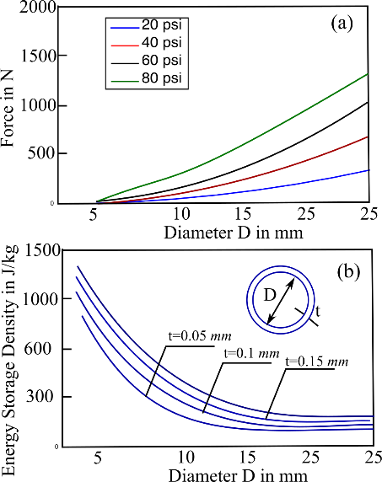

Fig. 5. Effects of scaling of FREEs on (a) actuation forces and (b) energy density.

Figure 4. Fiber Reinforced Elastomeric Enclosures (FREEs) and their spatial. deformation patterns

We propose a novel method to overcome the loss in performance of FREE-based actuators when miniaturized. These involve architectures of FREEs to simultaneously increase actuation stroke and stiffness in the joint. These translate to higher load-bearing ability and larger actuation displacements, beyond those permitted by using miniaturized FREEs, yet retaining benefits associated with wearability such as compactness and discreetness.

*FREE architectures for stiffness modulation.* Modulating stiffness increases load-bearing ability by providing support against an external load. We present architectures of FREEs for increasing the stiffness at joints based on antagonistic muscle activation in humans. For convenience, we shall demonstrate this on a one-degree of freedom elbow joint. The architecture aims to conform itself to the contours of the human arm around the elbow joint at any joint orientation. Once conformed, sufficient external forces are required to deform the joint.

The architecture consists of two groups of helically wrapped contracting FREE actuators (Fig. 6a). Each group is a double helix, consisting of equal and opposite wraps. Group 1 (green shown in Fig. 6a) wraps around the anterior end of the joint, while Group 2 (red in Fig. 6a) wraps on the posterior end. When not actuated, the FREEs loosely fit on the arm and do not affect elbow rotation. Now, by rotating the lower arm by an arbitrary angle (for example 45° shown in Fig. 6b or 90° in Fig. 6c) and then pressurizing the Group 1 family of FREEs causes them to conform to the shape of the rotated arm, along the anterior end of the joint. Any joint extension tends to stretch the Group 1 FREEs, and is thus resisted. This resistance is manifested as increased stiffness or support against the external load. However, joint flexion is unrestricted as it leads to a decrease in Group 1 FREE length, which is resolved by buckling. Now, pressurizing Group 2 FREEs (red) conforms them to the posterior end, thus offering stiffness against flexion. Simultaneously pressurizing both groups will lead to increased stiffness against extension and flexion.

In ongoing work, we proposed a simple analysis method to capture the increase in stiffness (Wehner et al., 2013) of the sleeve using the force obtained from a single FREE and modeling the friction between the FREE and the arm. A 3D printed model of the arm was fabricated for experimental evaluation. The stiffness of the arm was tested by applying an end load leading to a moment at the joint at two initial orientations of 0° (or straight) arm and a flexion of 30°. Torque vs. deflection were measured and plotted in Fig. 6d-e by activating different number of muscles per group (for example, there are two muscles / group in Fig.6a). As expected, resistance increased proportionally with number of muscles actuated.

*Fig. 6.(a-c) Preliminary prototype and demonstration of stiffness modulation for a 1-DOF-elbow joint using helical miniature FREE actuators, (d-e) benchtop stiffness tests on the joint at 00 and 300 orientations.*

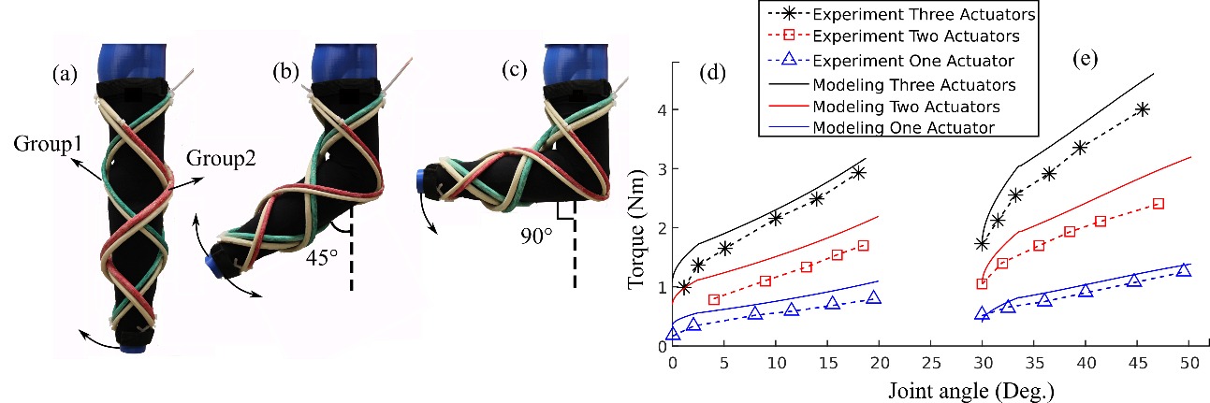

With bench top evidence of successfully providing static support, a preliminary wearable prototype was fabricated and customized for an individual’s arm as shown in Fig. 7a. EMG electrodes were inserted under the sleeve for measuring muscle activation levels of the biceps under two loading conditions (i) no load, (ii) hand holding 5lb. For both cases, the arm was flexed by about 85° about the elbow. The EMG data collected for the no load condition (Fig. 7b) shows a 70% reduction in the voltage when wearing the sleeve than without. This implies that the stiffening effect of the sleeve is clearly effective in offsetting the muscle power required to overcome the arm’s inertia. Further, wearing the sleeve showed a reduction in muscle activation of 20% with a weight of 5 lbs carried by the hand. Thus, we propose scaling of the present design coupled with actuation to increase the load-bearing ability of the exoskeleton, and help reduce physiological effort.

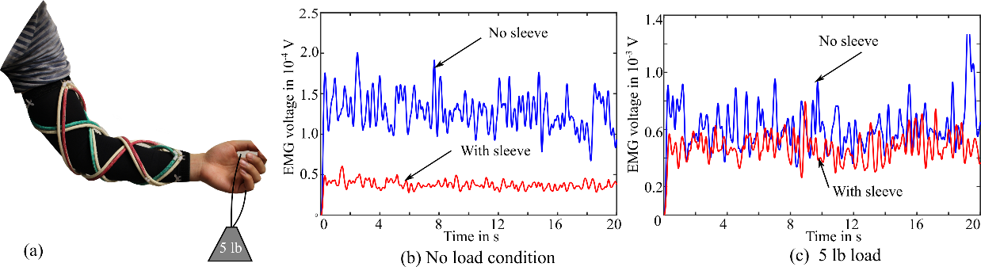

*Fig. 7. Preliminary testing of muscle activation levels (EMG) in biceps, under (b) no load, and (c) 5 lb load.*

*Nested FREE architectures for actuating joints****.*** Apart from stiffening, we have been able to provide modest actuation forces on the joint. Joint actuation can be achieved by placing linear actuators such as Mckibben muscles or FREEs along the forearm and the upper arm as shown in Fig. 8a similar to the works of Kobayashi et al., 2009. The linear actuator contracts, which creates a moment about the joint thus causing it to actuate. The angular displacement of the joint thus depends on actuator contraction or stroke, which for a FREE muscle is directly proportional to its length (Chou & Hannaford, 1996; Zhang et al., 2016). Our preliminary analysis revealed the need for a muscle with unusually large contraction ratio (> 40% of its length) to actuate an elbow joint by 900. Furthermore, sufficient forces (our analysis predicted 40 N) must be produced to lift the arm against its own weight. This can be difficult to produce with miniaturized FREE muscles since the elastic energy stored in the bladder limits the obtained stroke, and forces (Pillsbury et al., 2015).

We proposed an architecture that can increase obtained stroke and forces, yet maintaining a compact footprint (Fig. 8b-c). Such a nested actuator consists of two or more levels of FREE contracting actuators, whose overall effective length is greater than a single actuator occupying the same footprint (Fig. 8d). The first level of FREEs displaces Stage 1 with respect to the fixed stage. Stage 1 displacement is transferred to Stage 2 by passive FREEs or rigid members that carry compressive loads. Finally, a second level of contracting FREEs displace output stage relative to Stage 2. Thus, the overall displacement of the output stage is the sum of the contractions of both levels of FREEs. For the same overall length *Ls*, the nested arrangement gave a contraction of 30% compared to the 17% offered by a single FREE. While the two levels are clearly in series, each level can contain several FREEs in parallel (in this case 2). This can be used to tailor the force obtained from the output similar to prior work (DeLaHunt et al., 2016).

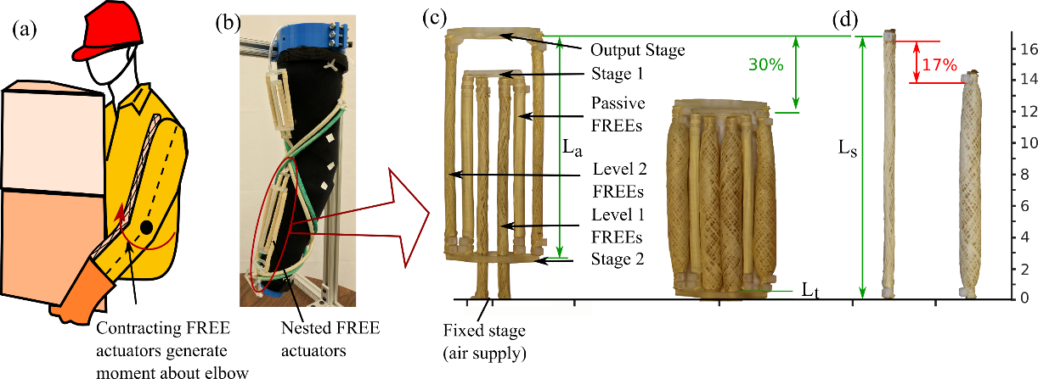

*Fig. 8. Nested contracting FREEs for joint actuation. (a) A single contracting actuator placed along the arm, (b) A demonstration of elbow actuation by nested FREE actuators, (c) construction and operating principle of nested architecture demonstrating significantly larger contraction ratios than (d) a single contracting FREE.*

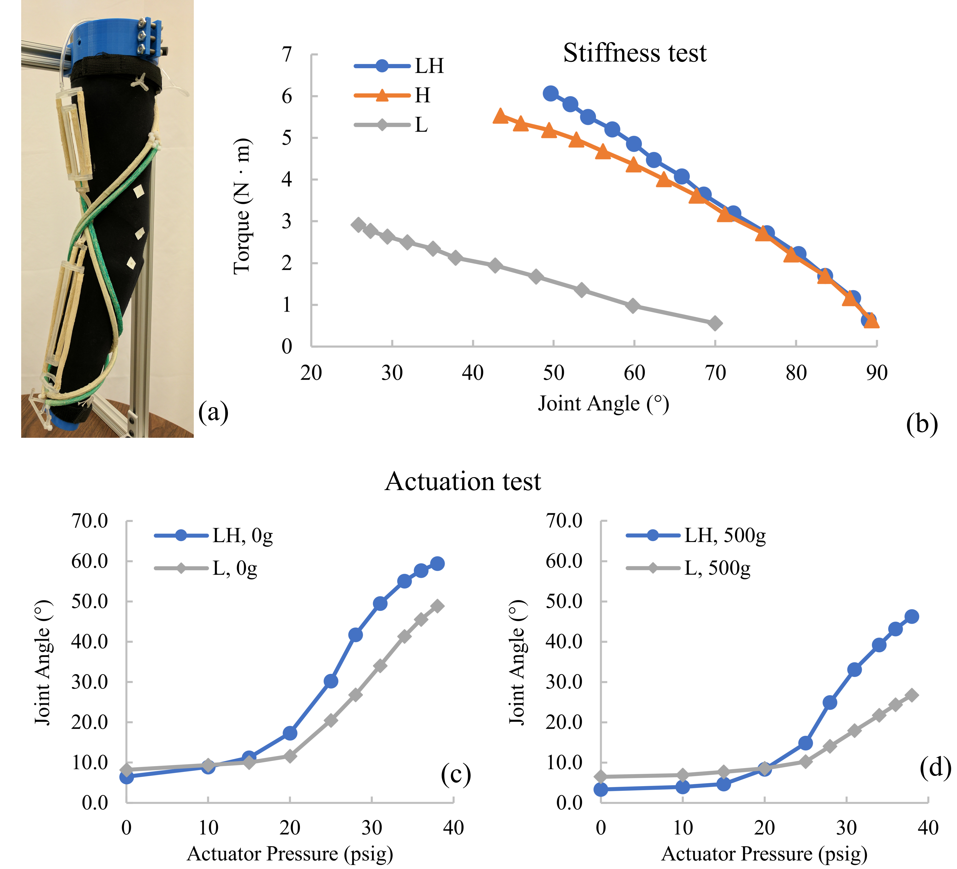*Combined actuation and stiffening.* Together, Drs. Krishnan and Hsiao-Wecksler have recently tested combining architectures with simultaneous actuation and stiffening elements (Figure 9a). The results indicate an increase in joint angle actuation (~100% increase as seen in Fig. 9d with a 500 *g* external load) and a moderate increase in stiffness against external load (~20% increase as seen in Fig. 9b) at lower joint angles. The increase in joint angle may be explained due to the combination of two effects: (a) the helical architectures aid in conforming the nested actuators to the contours of the arm leading to a larger leverage, (b) the helical architectures counter the inertia of the arm thereby enabling maximum contraction in the nested actuator. Furthermore, the joint exhibits a moderate increase in stiffness or load bearing ability at low joint angles, where the stiffnesses of both architectures add. However, at larger joint angles, the stiffness of the helical architecture alone dominates. To summarize, while the functionality of the two architectures are decoupled – the helical architecture stiffens and the nested architecture actuates - their combined effect leads to performance enhancement.

Fig. 9. Combining the effect of the nested and helical actuators is demonstrated to increase (b) joint stiffness and (c-d) joint actuation. LH:combination of linear and helical architectures, L: Linear nested architecture acting alone, and H:helical architecture acting alone.

*Exoskeletons and Powered Orthotics.* The field of wearable robotics is burgeoning; thanks in large part to the 2000 DARPA program for military exoskeletons, which resulted in the Berkeley BLEEX, Sacros XOS, and MIT exoskeletons (Zoss et at., 2006; Sarcos 2017, Walsh et al., 2007). A special issue of IEEE Robotics & Automation Magazine recently highlighted wearable robots (Guglielmelli, 2014). Researchers and designers must address a myriad of challenges to create successful wearable and/or mobile robotic devices, such as powered orthotics or exoskeletons for lower limb gait assistance or upper limb rehabilitation robots (Shorter et al., 2013; Asbeck et al., 2014; Ferris & Lewis, 2009; Roy et al., 2009; Moreno et al., 2014; Neubauer et al., 2014; Park et al., 2014; Sugar et al., 2007; Wolbrecht et al., 2010). Dr. Hsiao-Wecksler has developed the portable powered ankle-foot orthosis (PPAFO) research platform to address issues applicable to generalized challenges associated with *mobile* and/or *wearable* robotic devices for assisting people with disabilities (Shorter et al., 2011; Li et al., 2011; Li et al., 2013; Boes et al., 2014; Petrucci et al., 2013; Petrucci et al., 2015; Islam et al., 2016). Particular interest has been in addressing issues of control, runtime, weight, and bulk of pneumatically-powered human-scaled mobile robotic systems. Charged as a research testbed within the NSF’s Engineering Research Center for Compact and Efficient Fluid Power (Stelson, 2008, 2010), powered ankle-foot orthoses have been developed to highlight barriers and opportunities in compact, untethered fluid-powered robotic devices (Shorter et al., 2011; Neubauer et al., 2014; Chin et al., 2009). The PPAFO uses a small fixed-volume CO2 canister to drive a bi-directional pneumatic rotary actuator to provide plantarflexor and dorsiflexor ankle torque (Fig. 10). For control of the device, custom microcontrollers coordinate a suite of sensors (force resistive sensors, Hall Effect ankle angle sensor, and 9 DOF inertial measurement unit (IMU), valves, and regulators. Using these sensors and microcontrollers, different state estimation techniques, including artificial neural networks, have been explored to achieve appropriate gait function and timing (Li et al., 2011). In addition, we also created successful recognition and control approaches for operating in different walking environments (level ground, stairs, and ramps) (Islam et al., 2016). Later work involved an assessment to identify the minimum sensor suite needed for detecting gait events; performances of selected sensor configurations were quantified and compared through state- and event-based approaches (Wang, 2016). The design process used while developing the full system for the single joint PPAFO exoskeleton will guide the design process for the smart soft robotic exoskeleton used to address objectives 2 & 3.

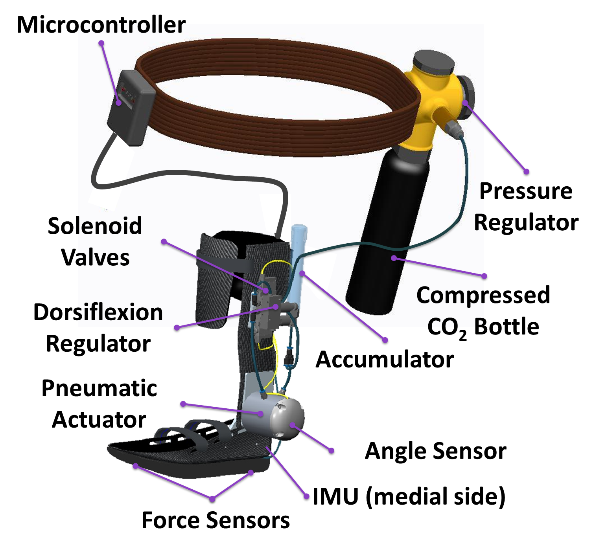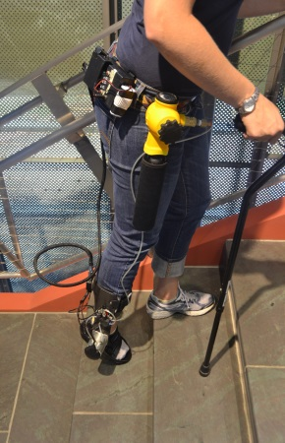

*Fig. 10. Portable Powered Ankle-Foot Orthosis (PPAFO).*

*Fig. 11. PVRM measurement device*

(a)

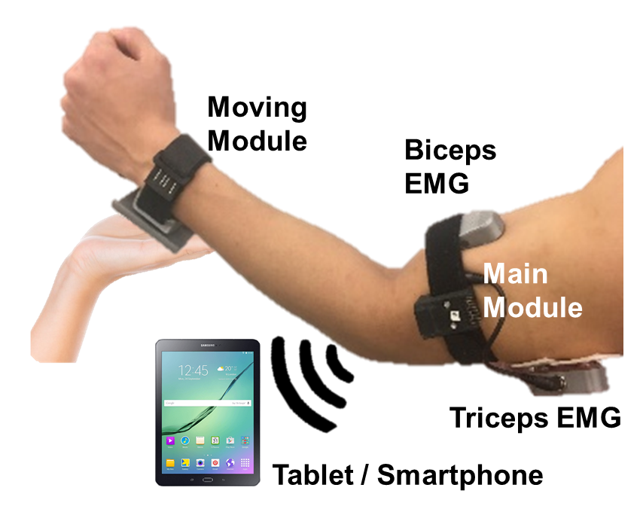

A recent project has been the development of a custom portable measurement device to assess joint behavior of a patient with hypertonic muscle tone (e.g., spasticity) while the patient's limb is passively stretched by a clinician. The Position, Velocity, and Resistance Meter (PVRM) is constructed from two compact, IMUs to compute joint angular position and velocity data, a load cell to compute muscle resistance, and custom EMG electrodes and circuitry (Song et al., 2017, Fig. 11). The IMU and EMG sensors will be integrated into the preliminary smart soft robotic exoskeleton for control of the exoskeleton and to assess physiological and mechanically intrinsic measures of the worker’s stress.

**RESEARCH METHODOLOGY**

(a) Stressful task

(b) Smart soft robotic exoskeleton

(c) VR assessment

*Fig. 12. (a) Alleviating physically taxing work tasks (b) using sensor suite with smart soft robotic exoskeleton (c) and tested in virtual reality environment of stressful workspace.*

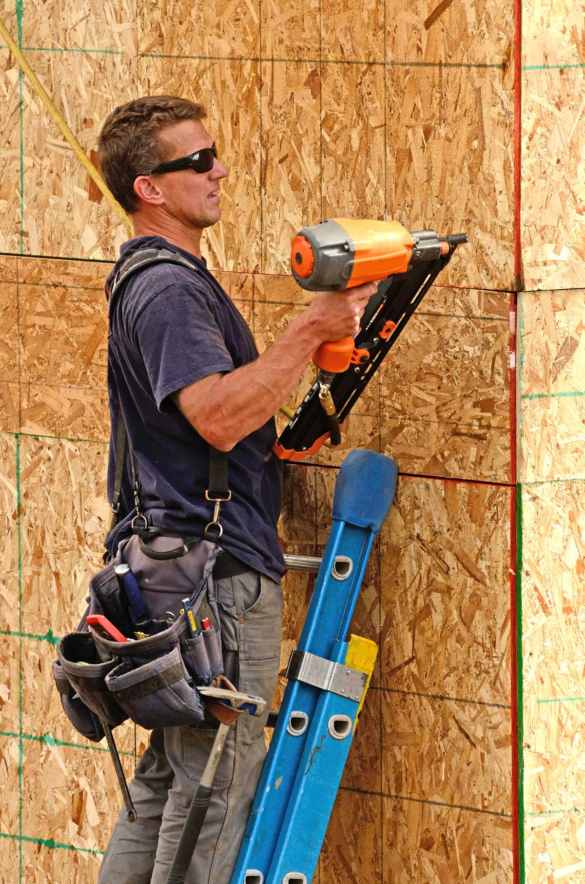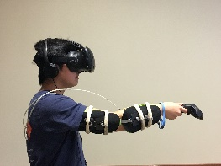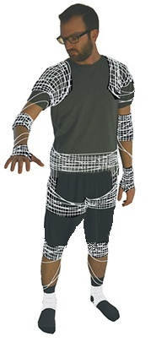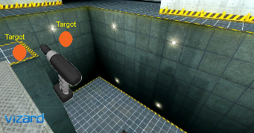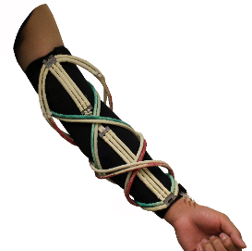

Sensor Patch (EMG, IMUs, etc.)

Helical Actuators

Nested Linear Actuators

fNIRS

ECG

EMG, GSR, IMUs

We propose an interdisciplinary project aimed to combine the real-time sensing of physical and mental stress in humans with state-of-the-art active soft robotic exoskeletons towards the development of integrated, intuitive, and responsive human-machine systems for use in stressful industrial work environments (Fig. 12). Our goal is both to lay foundational benchmarks in modern human-machine interfaces, and to build an engineered system which can be of real benefit to workers in industrial settings. To meet these goals, we will 1) identify the minimal sensor suite for monitoring anxiety and stress changes in real time; 2) create and validate stress-relieving active soft robotic exoskeleton; and 3) validate body-in-the-loop control of soft robotic exoskeleton.

***Objective 1:* *Identify* *minimal sensor suite for monitoring anxiety and stress changes in real-time.***

This objective addresses the challenge of sensing changes due to anxiety and stress in real-time, through the use of simulated virtual work environments (VWE) and integration of both electrophysiological and mechanically intrinsic measures. In order to provide a sensor suite for sensing anxiety and stress for use in a soft robotic exoskeleton, we will seek to identify a minimal sensor suite for detection of anxiety and stress in real-time in both young and older adults. To elicit stress, we will manipulate task difficulty through the use of a virtual tool handling task with variable accuracy and strength demands and manipulate environmental stress through the use of visual feedback of an elevated platform in the VWE, which will simulate working in an elevated environment such as construction work on a high-rise building or bridge. (Year 1: Drs. Hernandez and Sowers)

***Tool handling task (Experiment 1)***. Participants will be asked to move a virtual tool that they are holding as fast and as accurately as possible between subject-specific target locations, based on an individual’s reaching capacity. Participants will be asked to stand on force plates (Accusway; AMTI, Watertown, MA) while wearing a virtual reality head-mounted display (HTC Vive, HTC Corporation). Using custom virtual reality software scripts (Unity; Unity Technologies, San Francisco, CA), we will provide virtual representations of tools, as well as virtual targets for participants to use for guiding their volitional movements within a VWE. We will integrate visual cues presenting the start of the task, along with whole-body kinematics (optoelectronic motion capture system, Impulse X2 System; PhaseSpace Inc., San Leandro, CA, and custom IMUs [Song et al., 2017]), physiological data (i.e., skin conductance, muscle activation, and electrocardiogram data (ActiCHamp, BrainVision LLC) and cortical hemodynamics (fNIR Imager 1200, fNIR devices), and measures of ground reaction forces. User perception of physical effort will be assessed using the Borg Scale for Rating of Perceived Exertion (Borg RPE, Borg, 1990), and self-reported stress will be assessed using an 11-item scale (Holtzer et al., 2016). Task difficulty will be modulated using a speed-accuracy tradeoff paradigm based on prior reaching and whole body movement tasks (Fitts, 1954; Schmidt et al., 1979, Danion et al., 1999, Hernandez et al., 2012a, 2012b). To normalize across participants, the maximal forward reach at shoulder level will be evaluated for each participant (Duncan et al., 1990), and used for calculation of a pair of target positions at 90% of the maximal forward reach distance, with a separation distance of 40 cm (Fig. 12c). To manipulate target accuracy demands, three circular targets will be used with a diameter of 150% and 300% of the virtual tool tip diameter, based on the use of targets, with twice the diameter of the manipulated object, previously described in the ergonomics literature during pin transfer tasks (Fitts et al., 1954). To manipulate strength demands, we will use a tool weight of 5-lb and 10-lb (via wrist weights) while maintaining the same virtual tool representation, based on a typical range of weights of cordless power tools that can be used with a single hand. During testing, participants will be asked to move between targets ‘as fast and as accurately’ as possible for 30 seconds. To manipulate environmental stress conditions, two conditions will be examined: on level ground or on an elevated platform using just visual feedback in the VWE (Fig. 12c). Overall, 40 trials will be performed with 5 repetitions of each condition, with a pseudo-randomized counter-balanced design. To minimize the effects of fatigue, 1-2 minutes of rest will be provided after every 5-10 minutes of testing. Prior to testing, generalized anxiety, as evaluated by the State-Trait Anxiety Inventory will be used as a secondary measure (Gaudry et al., 1975).

Using multimodal data collected during the tool handling task, we will examine the physiological changes, based on frequency-specific fluctuations in heart rate dynamics, cortical hemodynamics and self-reported stress, that arise under stressful conditions in VWE. After validating that physiological changes occur in stressful VWEs, we will examine what mechanically intrinsic measures (i.e., force or motion) are best at detecting anxiety and stress by comparing against physiological measures of stress (i.e., skin conductance, electrocardiography, and cortical hemodynamics) in both young and older adults. A minimal sensor suite for monitoring anxiety and stress will be defined using an exploration of all 2-4 sensor combinations from physiological (i.e., skin conductance, muscle activation, electrocardiogram, and cortical hemodynamics) and mechanically intrinsic (force, kinematic motion capture data, and inertial data) time series data. Using a novel multimodal analysis framework using delay differential analysis (DDA) (Lainscsek and Sejnowski, 2013, Lainscsek et al., 2012, 2013a, 2013b, 2014), we propose to combine physiological and mechanically intrinsic time series data to improve the understanding and identification of stress or anxiety in real time (Fig. 15). DDA is a non-linear classification method that maps a recorded time series to a low-dimensional nonlinear functional basis. This allows for the extraction of non-linear features, amenable to classification, and robust under noisy conditions (Lainscsek et al., 2013b). These features will then be used to identify the most accurate combination of time series data in detecting stress or anxiety changes, based on frequency-specific fluctuations in heart rate dynamics, cortical hemodynamics and self-reported stress, during the proposed experimental conditions. The minimal sensor suite will then be used for experiment 3. We expect that absolute changes due to stress will be smaller in younger adults, but the noise levels in measures of older adults will be higher.

***Criteria for completion:*** To measure completion of this objective, we will demonstrate: 1) Physiological changes that arise under stressful conditions in virtual work environments using frequency-specific fluctuations in heart rate dynamics; 2) Correlation of non-linear features of mechanically intrinsic measures and physiological measures with self-reported measures of stress; and 3) Identification of a minimal sensor suite for monitoring anxiety and stress in real time using the area under the receiver operating characteristic curve as a measure of stress classification accuracy.

*Fig. 13. Processing pipeline for stress detection analysis. After data are run through training and testing algorithm, the resulting feature space for the now separated classes of data (green circles, blue diamonds) are divided by grey hyperplane. The weight matrix (W) maximizes separation while mapping to a 2-D space where classification takes place.*

***Objective 2:* *Create and validate stress-relieving active soft robotic exoskeleton*.** Through the use of pneumatically-powered miniature FREE architectures, we will create and validate the ability of a soft robotic exoskeleton to alleviate physical stress and improve performance accuracy via redistribution of loads and actuation. (Years 1-2: Drs. Hsiao-Wecksler and Krishnan)

This soft robotic exoskeleton will provide adjustable levels of joint actuation and stiffening to address the ability to modulate the amount of physical stress and effort needed when supporting handheld powered tools. We illustrated novel architectures of FREEs for the elbow joint, and successfully demonstrated the ability to support the joint against external load and reduce muscle activation. By recruiting combinations of helical and/or linear nested actuators and actuation pressures, the amount of support can be controlled. To address this objective, we will use this understanding of the basic FREE architectures to customize wearable designs for the shoulders, elbows and wrists into an upper body exoskeleton. In this task, we will build on the prior work to model stiffness and actuation behavior of the joints (Zhang et al., 2016). This activity will involve accurately predicting the forces and contraction of the FREE actuators (Zhang et al., 2016) with the inclusion of the nonlinear material properties of the bladder (Pillsbury et al., 2015). Benchtop testing similar to Fig. 6a-c will be performed to validate the model. The structure of the exoskeleton must account for proper load transmission from the robotic actuator to the human body to ensure the desired joint support. Structural consideration will include attachment of sensors and on-board pneumatic control components (values and regulators). Control of the exoskeleton will involve a tethered system controlled by a computer and DAQ system (Quanser Q8-USB, Markham, Ontario) to explore sensor and control algorithm options, similar to prior work by co-PI (Li et al., 2011; Islam et al., 2016).

After the completion of a prototype, initial assessments will be conducted to understand the impact of FREE architecture combinations, actuation pressure, and individual joints on load redistribution and actuation capabilities of the exoskeleton. We will use motion capture (6-camera, Qualisys AB, Gothenburg Sweden; and custom IMUs (Fig. 11, Song et al., 2017)) and electromyography (Bagnoli, Delsys Inc.) to establish joint kinematics and muscle activation patterns with and without static loads similar to Fig. 7 for variations in FREE architecture combinations, actuation pressure, and individual and combinations of joint support. Upon understanding how joint actuation and stiffening can be adjusted via these operational parameters, extensive testing will evaluate how these operational parameters can influence physical stress and performance accuracy.

***Tool handling task with exoskeleton (Experiment 2)***. Similar to the VWE tool handling task in Experiment 1, participants will be asked to move a virtual tool that they are holding as fast and as accurately as possible between subject-specific target locations, based on an individual’s reaching capacity. Using the maximal accuracy and weight capacity of each individual, participants will perform each of the experimental trials with variable physical demands (low vs. high physical demand), under conditions of no soft robotic exoskeleton, inactive soft robotic exoskeleton, and active soft robotic exoskeleton. During the active mode, the soft robotic exoskeleton will utilize a combination of load redistribution and actuation profiles for identification of the parameters that are best suited for alleviating stress in an individual subject. Motion capture, EMG, and Borg RPE measurements will be collected and used to examine changes in joint kinematics, targeting accuracy, muscle activation, and user perception of physical effort in these exoskeleton test conditions.

***Criteria for completion:*** To measure completion of this objective, we will demonstrate: 1) a soft robotic exoskeleton architecture that allows for the performance of repetitive work tasks; 2) changes in physical performance and movement strategies arising from the use of a soft robotic exoskeleton; and 3) identification of a load redistribution and actuation profile that best alleviates stress and anxiety in an individual subject.

***Objective 3:* *Validate body-in-the-loop control of soft robotic exoskeleton***. Integrating the sensor suite that can most accurately assess changes in stress or anxiety during the performance of industrial tasks, and the actuation pattern that can best alleviate mental and physical stress and improve performance accuracy, to systematically define how signals of stress interact with machine and drive what the machine is doing. (Year 2-3: All PIs)

Sensing and control of the exoskeleton involves multiple stages. We will integrate the minimal sensor suite for monitoring anxiety and stress (Objective 1) to monitor the worker’s physiological state into the soft robotic exoskeleton (Objective 2). To create portable self-contained systems, we will use our experience with wearable technologies (Fig. 11, Song et al., 2017) to integrate these sensors into flexible smart soft robotic exoskeleton module structures.

***Modified high stress tool handling task (Experiment 3)***. Similar to the high stress tool handling task, participants will be asked to move a tool that they are holding as fast and as accurately as possible between subject-specific target locations, based on an individual’s reaching capacity. Using the maximal accuracy and weight capacity of each individual, participants will perform each of the 4 experimental trials with variable physical demands (low vs. high physical demand) and variable environmental stress (low vs. high stress), under conditions of inactive vs. active soft robotic exoskeleton. Using a minimal sensor suite, levels of mental and physical stress will be monitored in real time, to be used for controlling the feedback from the soft robotic exoskeleton. Overall, 40 trials will be performed with 5 repetitions of each condition, with a pseudo-randomized counter-balanced design.

In order to be effective, the feedback system will need to measure the relevant ‘state’ of the human in the loop. Since measurements involving humans are often noisy and contain significant idiosyncrasies, our proposed work focuses on several challenges: 1) State estimation in the face of noise; 2) Sensor fusion and spatiotemporal scales; and 3) System identification and idiosyncrasies. Using simple reference models, such as a perturbed stable ODE: $\dot{x}\left(t\right)=-α\left(x\left(t\right)-\overline{x}\right)+g\left(t\right)+ξ(t)$, where the process x reflects the ‘state’ of the human, with reference value $\overline{x}$. Using a threshold, $\check{x}$, we will be able to identify a state of elevated anxiety or stress if $x\left(t\right)>\check{x}$. However, x will be only estimated through noisy observations of intrinsic mechanical or physiological time series data, which may themselves reflect different timescales and dependencies on $x$. Within the dynamics of *x*, the driving term *g* represents deterministic response to stimuli, and $ξ$ represents noise. Individual tuning of system parameters $α$ and $\overline{x}$, as well as the reference value $\overline{x}$, will likely be needed as they are expected to vary from person to person.

***Criteria for completion:*** To measure completion of this objective, we will demonstrate: 1) Integration of stress and anxiety sensing with actuation of a soft robotic exoskeleton during the performance of industrial tasks; and 2) Identification of a feedback system that can monitor changes in stress and anxiety in the worker to provide the basis for an intuitive and active soft robotic exoskeleton.

***Subjects*.** For experiments 1-3, we will recruit 20 healthy young adults (18-35 years of age) and 20 healthy older adults (50-70 years of age) for each experiment outlined below, for up to 60 young and 60 older adults over the 3-year period. Participants will be recruited from the local community in Central Illinois and from ongoing studies in the PIs’ labs. All subjects will have normal or corrected to normal vision and no previously diagnosed musculoskeletal or neurological condition.

*Sample Size Calculations*. To estimate the optimal sample size in experiments 1-3, we used an a priori sample size calculation for a repeated measures analysis of variance with within- and between- subject interactions using G*Power 3 (Faul et al., 2007). To detect a significant effect at the p=0.05 level with .95 power, .25 effect size, and 5 repetitions, 16 subjects in each cohort in experiments 1-3 will be required.

*Statistical Analysis*. A mixed design ANOVA will compare healthy young vs. older adults, with accuracy demands (low vs. high), strength demands (low vs. high), and environmental stress (low vs. high) as repeated factors, on each dependent variable for **Experiment 1**. A mixed design ANOVA will compare healthy young vs. older adults, with physical demands (low vs. high) and experimental condition (no soft robotic exoskeleton, inactive soft robotic exoskeleton, and active soft robotic exoskeleton), on each dependent variable for **Experiment 2**. A mixed design ANOVA will compare healthy young vs. older adults, with experimental condition (inactive vs. active soft robotic exoskeleton), physical demands (low vs. high), and environmental stress (low vs. high), on each dependent variable for **Experiment 3**. Bootstrap hypothesis testing (Liu 1988) will be used if the residuals are found to be significantly non-Gaussian. We will correct for multiple comparisons using a bootstrap version of version of the Holm/Hochberg adjustment (Troendle 1995, Romano and Wolf 2005) that corrects for dependence among the test statistics and thereby improves power while maintaining a family-wise error rate of 0.05.

***Possible Problems and Alternative Approaches*:** Intrinsic mechanical measures may not be sufficient to detect stress and anxiety changes. Thus, a combination of physiological time series measures will be used to provide a ‘ground truth’ in the detection of anxiety and stress in virtual work environments. Alternative sensors for detection of stress and anxiety include flexible skin-mounted ‘tattoo electronics’ which through wireless connectivity might provide integration of EEG, EMG, and inertial data with the soft robotic exoskeleton (Ma et al., 2010; Jeong et al., 2013). Small portable and wireless near-infrared sensors may also provide an alternative for evaluating changes in cortical hemodynamics associated with stress, while instrumented insoles will provide an alternative to force plate data. In addition to a threshold level approach for detection of changes in anxiety or stress, nonlinear methods of classification such delay differential equation analysis (Lainscsek et al., 2013a, 2013b) may be explored for controlling the feedback from the soft robotic exoskeleton. Miniature pneumatic FREEs may not be strong enough to actuate or support the limb/joint for our target applications. In such circumstances, larger-diameter FREEs may be explored, since FREE force scales with diameter (Fig. 5). Alternate approaches could be the use of high pressure liquids for actuating FREEs, which may enable further miniaturization. However, this design will be hydraulically-powered leading to challenges of leakage and portable power supplies. Other kinds of actuation techniques could be explored, such as tendon driven mechanisms using DC motors arranged in the same architecture to independently modulate stiffening and actuation of the joint.

**BROADER IMPACTS**

1) *Benefits to society.* In addition to the development of a state-of-the art soft robotic device, the exoskeleton will provide a platform for testing human-in-the-loop control, which has major ramifications for significantly enhancing our understanding of subject-specific dynamics of stress during the performance of goal-directed physical tasks. The ability to sense and detect stress opens up the doors to potential applications such as active shirts that can respond to stress and provide intuitive actuation that may be used for alleviating typical symptoms of persons with anxiety or behavior disorders. In addition, the proposed research may provide significant insight into how physical and physiological changes in state interact with an intuitive and active exoskeleton, but also how a soft robotic device may shape tool handling performance and risk of injury in both industry settings and in the general community.

2) *Broad Dissemination*. This research addresses the NSF CMMI M3X’s interest in an integrated treatment of human intent, perception, and behavior in interaction with embodied and intelligent engineered systems as mediated by motor manipulation and will provide de-identified data to be shared for public and potential secondary uses, while summary forms of these data along with metadata will be available to other researchers via conference proceedings, peer-reviewed journals, and academic social networks. Our goal is to improve diversity in the STEM workforce. To maximize the impact of the proposed research, we will leverage problem based learning (PBL) approaches to improve educational outcomes of undergraduate and graduate mathematics, science and engineering students, while enhancing participation among underrepresent minorities. PBL is a teaching strategy where learning is driven by messy real-world problems that promotes active learning and group collaboration. Through the development of problems and cases, we will aim to incorporate transdisciplinary projects that will allow students to increase their understanding of course content, gain a broader appreciation for other disciplines, and enhance their problem solving skills, in courses in the kinesiology, computer science, robotics, mathematics, and engineering. The project will act as a platform for collaboration between students (undergraduate and graduate) and investigators from kinesiology and engineering. Undergraduates will receive independent study credit. This project will support the creation of opportunities for students that are interested in design and robotics through the investigators’ current and future design and biomechanics courses. These courses will highlight opportunities for product design, robotics, and assistance to a variety of populations including people with disabilities. The project will also leverage the recently announced campus-wide Illinois Design Initiative and Seibel Center for Design at the University of Illinois where students from all disciplines will be encouraged to participate in curricular, co-curricular and extra-curricular design-related activities.

At the community level, we can apply our newfound understanding of FREE behavior to the concept of democratized design at the Champaign-Urbana Community Fab Lab by teaching C-U locals how to produce their own FREE actuators. The design challenges faced while developing this exoskeleton will be applicable to a wide variety of projects, and could lend valuable experience to passionate makers. Through the development of integrated smart soft robotic exoskeletons and virtual reality environments, we will be able to provide educational demonstrations to the local community through partnerships with the Center for Wounded Warriors at UIUC. To raise awareness about occupational challenges and musculoskeletal disorders experience by the industrial and aging workforce, the research team will share their work at the following activities: Annual participation at UIUC’s Engineering Open House and the Beckman Institute Open House. These events bring over 20K visitors (K-12 groups, college students and general public) to the UIUC campus over a two-day spring weekend to experience student-organized exhibits. Annually, the PIs and their research groups contribute lab tours and half-day activities during high school student summer camps (coed and female only) and high school visitation programs by the Society of Women Engineers. Activities will be updated for material from the proposed project.

3) *Participation of underrepresented groups*. As a first generation Nicaraguan immigrant, the PI will continue to recruit underrepresented students to the fields of science and engineering through direct one-on-one meetings with students applying for college, mentoring of undergraduate and graduate students from diverse backgrounds, and development of outreach events. As an assistant professor at UIUC, he will continue to contribute to broadening the participation of under-represented groups STEM fields through the development of outreach activities in neuroscience and biomechanics aimed at K-12 students. Through participation in Illini days, where high school students from underrepresented groups in STEM fields visit campus for instruction and hands-on lab experiences, and the local BRAIN awareness day, where younger children (K-5) are exposed to topics in neuroscience, it is our goal to foster excitement for the study of STEM fields in the next generation of scientists and engineers. The project will seek to increase diversity and inclusivity in our research and outreach activities through recruitment of underrepresented students, such as females in engineering, and people with disabilities such as students from UIUC’s large wheelchair and wounded veteran community.

**RESULTS FROM PRIOR NSF SUPPORT:**

The NSF has not provided any prior support to the PI.

*PI Sowers: CMMI 1727785, $500,000, 10/1/2017- 8/31/2020. Signatures and Barcodes: Data-driven Understanding of Transportation System Performance during Extreme:* This work focuses on modelling and analysis of large traffic patterns. The focus is on ways of understanding topological descriptions of traffic interactions and in understanding extreme events. IM: This work brings the notion of persistent homology into play in understanding connectivity of traffic events. This work also develops a number of linear algebraic perspectives on large amounts of traffic data. BI: Some of this work has already been presented at industrial computational venues (JupyterCon) and at the IEEE 20th International Conference on Intelligent Transportation. Parts of this work are being showcased through a partnership with the Midwest Big Data Hub and datascience.com, and in collaboration with the Illinois Geometry Lab.

*Hsiao-Wecksler and Krishnan were Co-PI on Project 2F.1 ("Soft pneumatic actuator for arm orthosis", 6/1/14-5/31/16, $90,652 to H-W, $111,848 to Krishnan), subaward of NSF ERC grant “Engineering Research Center for Compact and Efficient Fluid Power,” (ERC-0540834, 6/1/06-5/31/16).* IM: Exploit the compact and lightweight nature of pneumatic soft robotics based on FREE actuators to develop powered upper extremity orthoses. BI: Focused on development of arm orthoses for used during gait with pediatric crutch users. Selected Pub: (Singh et al., 2014; 2015a; 2015b; 2016; Xiao et al., 2016). 1 US utility patent application (Hsiao-Wecksler et al., 2015). Work from this project was used for this proposal.

*Hsiao-Wecksler was PI on Testbed 6 (Human Assist Devices), subaward of NSF ERC grant “Engineering Research Center for Compact and Efficient Fluid Power,” (ERC-0540834, 6/1/06-5/31/16, $1,214,266 to H-W)* IM: Developed world’s first portable pneumatically-powered ankle-foot-orthosis for gait assistance of people with disabilities. Used research platform to address challenges in control, runtime and function of portable and wearable robotic devices. BI: Device tested with people with Multiple Sclerosis and Parkinson’s disease. Selected Pub: (Boes at al., 2013; Chin et al., 2009; 2012; Islam et al., 2013; 2016; Li et al., 2011; 2013; Petrucci et al., 2013; 2015; Shorter et al., 2011a; 2011b; 2013). 1 issued US patent (Hsiao-Wecksler et al., 2016), and 1 US patent application (Hsiao-Wecksler et al., 2011).

*Krishnan is PI on “CAREER: A Design Methodology for Bio-Inspired Soft Mechanical Systems” (CMMI#1454276, 2/1/2015-1/31/2020, $500,000).* IM: The project seeks to formulate a systematic design methodology for soft mechanical systems, especially soft fluidic actuators to generate reconfigurable constraint behavior and attain dynamic spatial configurations such as a knot. BI: The project seeks to enhance ease of designing soft structural embodiments for use in assistive devices, surgical devices, space exploration and manufacturing automation. The project aims to engage with high school students through a bio-inspired design program. Selected Pub: (Patiballa, Stanley, & Krishnan, 2016; Satheeshbabu & Krishnan, 2016a; 2016b; Singh et al., 2016).